English

The Ring in Hellas Makoto ADACHI
(alpo Japan)

abstract
It came to see a ring pattern in the southern part of Hellas by the image clearly in September, 2005. Then, whether this ring pattern had been seen about when was pursued. Only little material is at hand in me. This recording however was found ..the image in 1939... There seems to have been a ring pattern from of old.

Ring pattern that got into the news this year
The following images were gotten at the observation season of 2005.
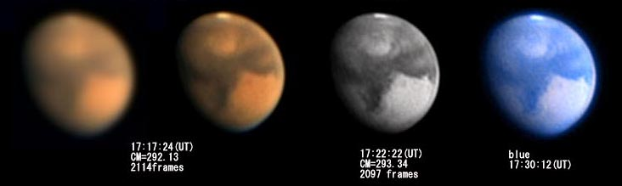
image by A.Hatanaka 2005,09,01 (UT)

This image sees an especially clear because of IR (the 3rd from the left) ring pattern by the one of A.Hatanaka. It seemed that it was a peculiar appearance that had not been noticed in the past. It looked the following in the author's visual observation in 2005.

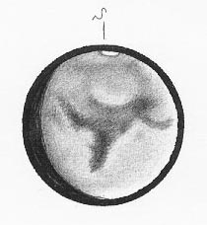
2005,09,02 16:50(UT) observr: M.ADACHI
CM=276.3 De=-12.6 Ls=280.8 Dia.=14.3
Zea Lacus is dark seen.

This ring pattern of Hellas cannot be clearly caught by the visual observation. It seems not to see it if the condition is not greatly satisfactory. However, when the past observation example is seen, some drawing and image that it seem are found.

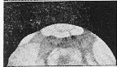
Drawing by S.Ebisawa in 1956
Bright spot is seen in the south of Zea.

There is dark shade part (Zea Lacus) in the north side soon about this ring pattern. The same appearance as this is seen many times repeatedly in the past though the center of this Zea Lacus has been biased from the center of Hellas to the south this year.
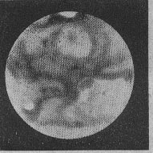
This drawing is a E.M.Antoniadi's in 1924. It looks like very well for how to see Zea Lacus at this season. Perhaps, it is guessed whether there was a ring pattern at this time. The reason is that there are the following images.
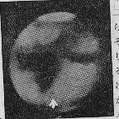
This image is Mars of which E.C.Slifer took a picture in 1936.
The image that looks like this year well is obtained. The position of the ring pattern is central inclined to from this year. The position will not become a problem because it will not seem that geographical features takes part. It is likely to become evidence to assume that it will be related to albedo and to appear.
Moreover, the following one is seen in a recent image.

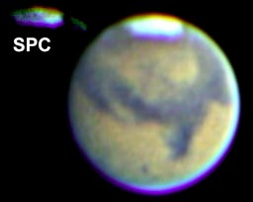
image by N.Ito Mars of 2003 image by P.Clay Sherrod

Then, the ring pattern is lightly admitted in these two images though it is. Moreover, the following image of Yunoki is clearly admitted.

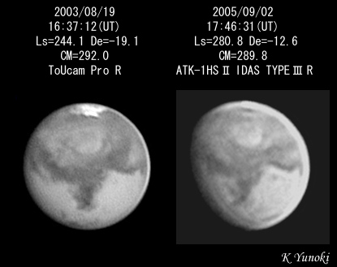

From this to not special ring pattern of Hellas this time. As for the ring, it is understood to seem to have come into view clearly from the image data processing's advancing. The image of HST in 1990 is for your information published.
(reported 2005, 09, 26)
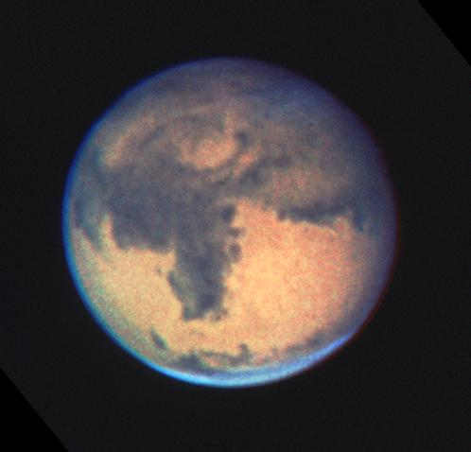 by HST in 1990

００５ Opposition
Origin of appearance of ZEA
Makoto ADACHI

Zea looks dark, and shows a dark appearance to the center of Hellas at the observation season of 2005. This appearance becomes a very big darker than 2003, extension. In the report that had been written in September, 2005, it was pointed out that there was a ring pattern in the southern part of Zea. And, it was pointed out I am to seem to see it for a long time.

I do not think the report that blazes the origin of the pattern of this Zea to be before. I looking report on the one that becomes the cause to here because I began to be while being arranging past material etc.

The Pattern Originates In Geographical Features.
It is made it emphasizing an advanced difference though figure below is a map of all aspects of Mars. When only Hellas was expanded among these, it became a way below.

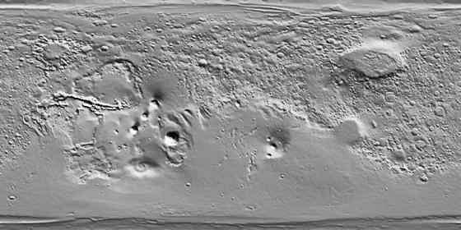

When this image is seen, it is understood that there are a considerably clear ups and downs in the Hellas basin. It compares it with the image from which this image is taken at HST and the season of now. The relation to geographical features is sure to come into view from this work. Moreover, what pointed out that it is a state of the ring when carefully seeing seems to be related to these geographical features.

It is easily imaginable that Zea becomes various hows to see it as a result of
the black blizzard.

These images is south up.
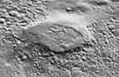
Hellas is a basin, and the region where same thing as the dune a lot is found. Moreover, it is understood that the wind is a violent region. It seems that there are some relations between the part and the geographical features that is darkly reflected with a definite cause though it is not possible to say.
(reported by 2

