Martian Dust Storm in 2005
ALPO-Japan Makoto Adachi

1 Preface.
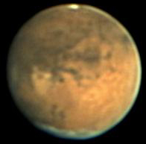
The duststorm occurred in the Cryse plain of the Martian surface in October, 2005. For 2005 years, it was cutting down the SPC at the time of the extreme approach. Those days for diameter to be increased were expected a duststorm occurrence.
The duststorm occurred in the Cryse plain as the expectation on October 18. A scale became the extent of 70degrees (longitude) in the middle scale. An early course couldn't be observed in Japan. The areas of the observation condition which were good were Europe and United State of America. Generally duststorm saw it, and it was divided into two times, and occurred. The first development in this could be seen in Japan. Last report arranged the development which happened at the first occurrence stage. Then, it tried to examine it about the occurrence mechanism of duststorm.

２ The development of dust storm
The initial stage (the first stage) of this duststrom showed an interesting figure. It became the letter type of V in the Cryse plain, and came to the sight with duststorm like an upper image. This first figure is very rare. Therefore, an observation person expected what kind of development to become greatly. Though it couldn't be observed in Japan, many observation reports were gathered by HP of ALPO-Japan.
Mr. Yuichi Iga of our member made the animate cartoon of duststorm by using those records. The person who has the Internet seen wants to show the next URL.
http://alpo-j.sakura.ne.jp/kk05/duststorm_051018.htm
The duststorm progressed in the south. This duststorm had the figure divided into the left (the east) and the right (the west side). So, it was decided that I chased each. A position on the Martian surface was measured by using WinJUPOS in the position.
In the beginning, it considered that duststrom of the east and west both proceeded in the south. But, a movement became unexpected development from the beginning. The duststorm of the left (the east) wasn't moved at all on 19 of the next day. This was unexpected development. It is because it was as it stops though it guessed it from the shape and the past example and proceeding in the south was considered. Instead, duststorm of the right (the west side) was developed suddenly. It went into what and the Marineris valley as it is.
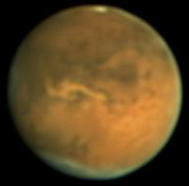
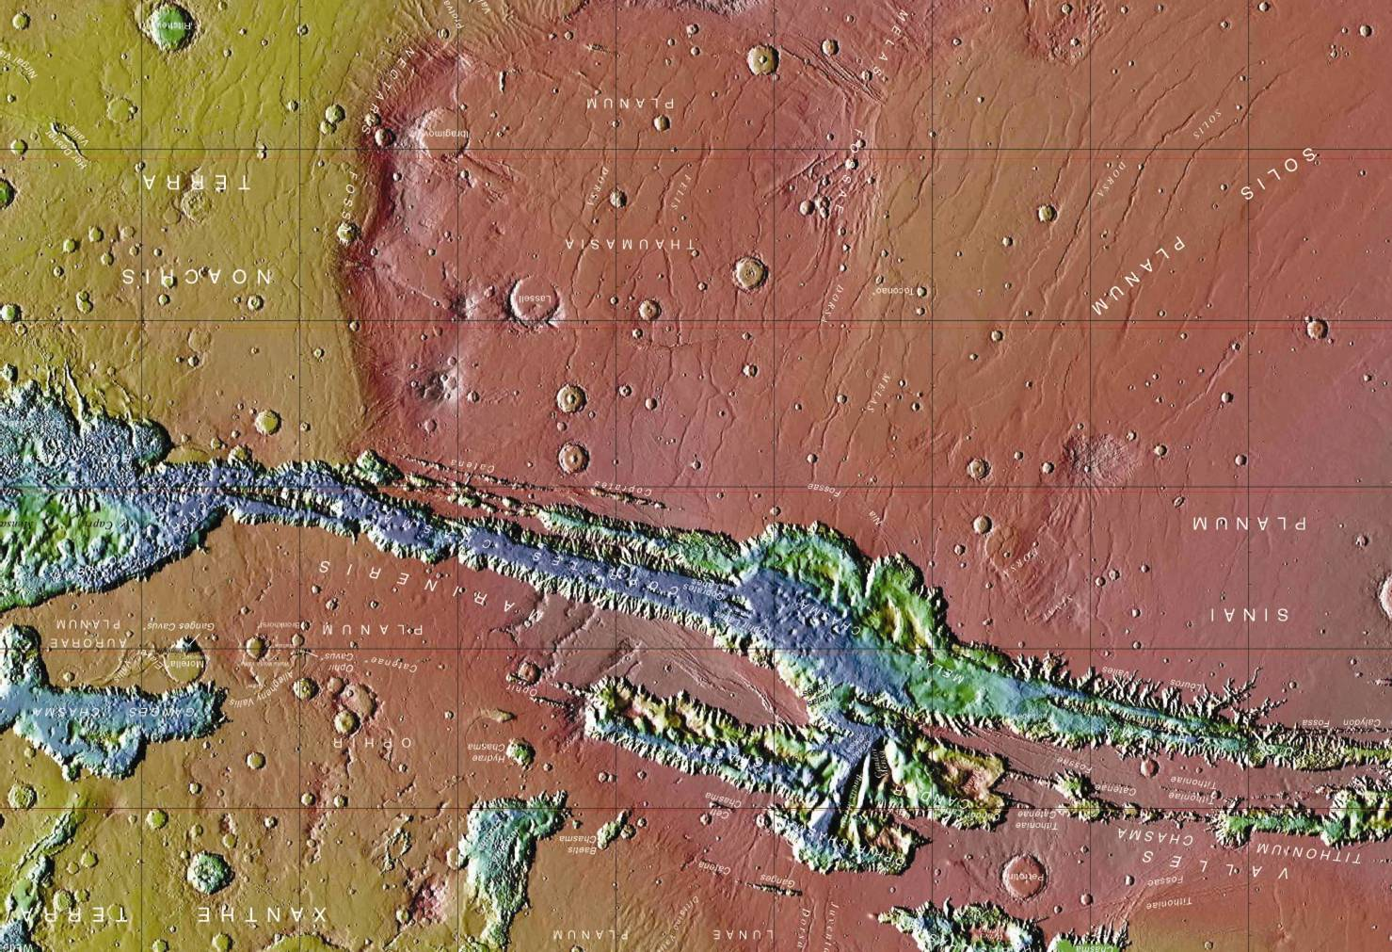
When a figure is compared, it knows collation with duststorm and the Marineris valley well. The shape of duststorm and the shape area of the valley apply properly. The duststorm didn't pass on the upper valley, and it got into the valley. Though it is mentioned later, I think that this nearby valley is the part where temperature is lowering. Temperature at the top of duststorm which occurred in the Cryse plain isn't thought to be so high. If temperature is high, duststorm is supposed to pass on the Marineris valley.
For 19 days, the figure which spread out only in the right (the west side) was confirmed with duststorm.
For next 20 days, brightness lowered with duststorm in this Marineris valley. Then, it stagnated in the same position. However, the new figure which should say the second wave of duststorm to being surprised, too, was observed. The figure which spread out around Mare Erythraeum which became the south of the Marineris valley greatly was recorded in it. It can think about duststorm in the (Figure reference.) Marineris valley with the thing that it didn't change and which was completed newly.

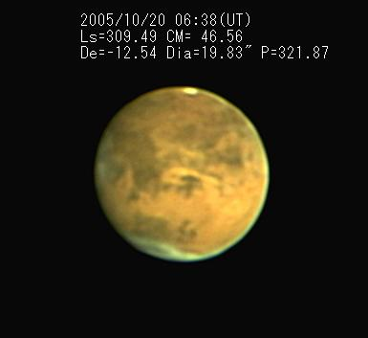
Furthermore, 2 new brightspots next 21 days occurred in the south. Brightspot occurred around Solislacus as well. BS which it seemed to be 20 days of the previous day isn't moved, but both can be seen as a new spot. It spread greatly on 22. Development until 21 was the state that it was very much interested.
I have thought that duststorm is moved by the observation till now. But, I observed last phenomenon, and I could not but have new thought. Mr.Minami (OAA Mars recorder) announced that an occurrence place was moved one after another in the Mars conference in 2004 (Noto Japan). Last duststorm was really the same way. Well, why is a source of occurrence moved? I want to try to proceed with the thought one more step.
image by Jim Phillip Oct.20th

3 the movement of a source of occurrence of duststorm.
It tried to show the occurrence place of this duststorm on the development figure. The place where duststorm occurred first was located in the south of the Cryse plain. The occurrence place of duststorm wasn't necessarily observed in the occurrence time. Therefore, measurement value can't be selected as an occurrence position. If it supposes to be hard to move, the position of duststorm will be allowed to think about this position as an occurrence position.
This occurrence position is measured value by using WinJUPOS.

<October 18>
The occurrence point (tentative name A point)
left bright spot 34degrees(W) -13degrees
right bright spot 49degrees(W) -10degrees
<October 19>
New bright spot is not seen.
<October 20>
The occurrence point (tentative name C point) of the bright spot on the east side of Solis Lacus.
53degrees(W) -27degrees
<October 20>
The occurrence point (tentative name D point) of the bright spot on Erythraeum.
60degrees(W) -42degrees
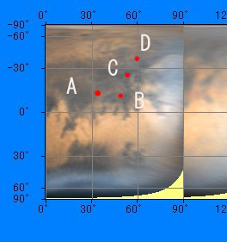
A new bright spot wasn't seen on October 19. This day is the day when duststorm got into the Marineris valley dramatically. So, the occurrence position of four upper bright spots was shown in the development map. I examined whether some relation was not in the occurrence place and the geographical features. An arrow showed the approximate position of the occurrence place of duststorm. As for the numerical value, I want it to agree to some times of errors' being.
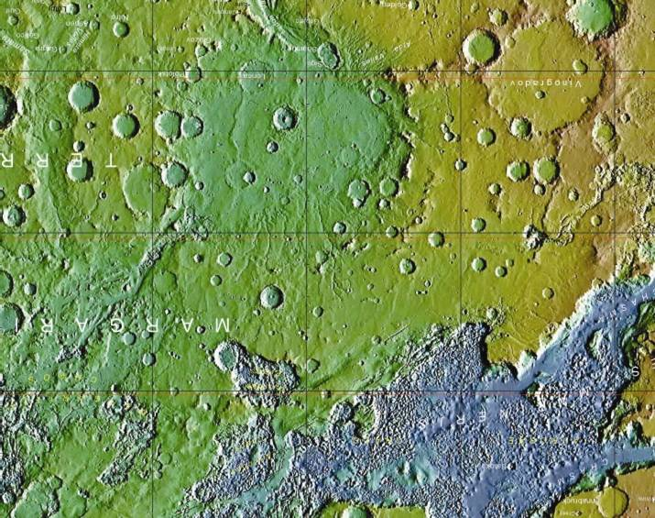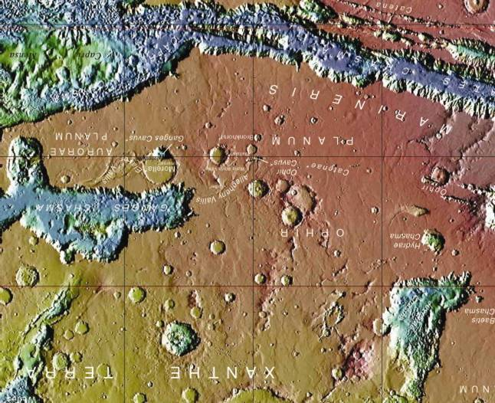

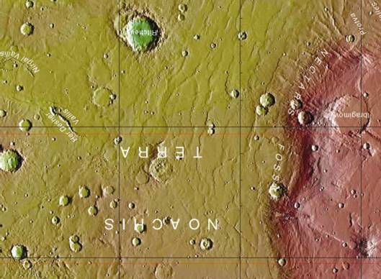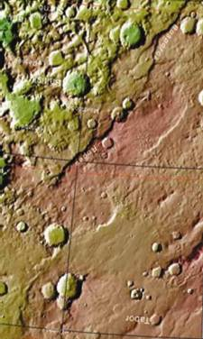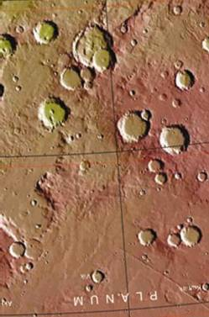
It tried to examine the relations with the occurrence point and the geographical features of this duststorm on the topographical map. As for the point of A・B・D, it is understood that there is surface of the earth near here. It seems to have some relation with the occurrence of duststorm, and to think of this fact. ( As for this, it is stated later.)
BAA puts the occurrence point of past duststorm together. I want to examine these one after another and in detail from now.

4 Is it a sign phenomenon?
The occurrence day of duststorm is October 18. But, dust veil is observed on October 16 before it. This may be a sign phenomenon. A place is just the west side of Mare Achidariumu (30W, +50). Mr. Damian Peach observes it from the north to the Nilokeras (W50, ・30) neighborhood. It has the possibility that the flow of the atmosphere which made the cold the subject from the Arctic direction proceeded in the south through this part.
It goes from the north pole to the middle latitude in this time, and it is not rare that duststorm is seen.
This has the possibility that it is the sign phenomenon of this duststorm. It is disappointing that the state that the amount of information was poor this time and got clear couldn't be taken with being disappointed.

- The relations with the occurrence point and the geographical features of duststorm.
Though I stated it by upper 4, relations with duststorm and the geographical features (Geographical features like a Marineris valley) are thought to seem to be strong. As for the scooped geographical features, the surface of the earth concentrates even the inside of the Mars on a part.
It doesn't get clear what kind of cause geographical features like a Marineris valley occur in. A valley like the branch of the circumference and a mountain could do that water in the ground evaporated in the atmosphere from the cliff. A hollow is formed in the ground, and the surface of the earth sinks in the bottom, and it is said that it could be probably done due to the evaporation. So far as the image of the probe is certainly seen, there are many geographical features which can understand that it is interpreted like that very much.
Vapor is radiated in these areas in the atmosphere from the surface of the earth. (There is an opinion of CO2.). The radiant heat from the sun of the day when Mars and the sun approached it most is especially very big. It has been calculated since the furthest time since it is 1.4 times.
Many duststorms occur when it passes the time which is the closest to the sun. This shows the influence of the radiant heat from the sun. It is warmed, and the surface of the earth rises as for atmospheric temperature. An atmospheric movement by atmospheric heat tide teide action in one day will be concerned greatly. And, it will happen every time if the cause of only this becomes close to the sun. But, duststorm doesn't actually happen every time. Relations with the vapor radiated in the atmosphere from the amount of ice buried in the underground and that have some relations.
As for the atmosphere of the Mars when it passed the time which was the closest to the sun, temperature rises in the daytime. The atmosphere warmed because of the atmosphere whose atmospheric pressure was low leaves the surface of the earth. Therefore, the movement of the warmed atmosphere must think about the distribution of the sky. But, there is some only information by the probe such as Viking, and these data become the territories of the model calculation chiefly. I must read a studied thesis because the calculation said like this can't be done. The atmosphere warmed when it tried to examine it has big extent to the sky.
It thinks that there is some water ice in the underground of the Mars. It suffers radiant heat from the sun, and that ice will evaporate. Or, it may flow out from the cliff. When vapor comes out into the atmosphere, atmospheric temperature around the surface of the earth will decrease. Usually, the atmosphere is warm. Temperature around the surface of the earth lowers when the vapor which got cold from the underground comes out. Then, atmospheric will be structure two steps (by the heat absorption of drifting dust). The whole of the area doesn't become double structure with this phenomenon. Such a phenomenon is supposed to happen in the small area of a release of the vapor where it happened. This becomes an atmospheric structure like the cold front of the earth. Because of course a difference in temperature is remarkable, it is decided that strong wind is made to occur. This will be the basis of the duststorm occurrence.
It will be the daytime to take the influence of the radiant heat that this atmospheric two-step temperature structure happens clearly. The top of duststorm which began to flow from the extreme neighborhood is moved to the south. It develops into the wind which rolls up sand when it comes to the position (about noon) to suffer radiant heat, and becomes duststorm. It can think that it can be seen as duststorm that it is observed from the earth.
The Great duststorm occurs when there is much radiant heat from the sun by the large-scale figure of this. And, the atmosphere is observed in dusty in the year when The Great duststrom in recent years occurred.

- The wall of the south latitude 50 degrees

After duststrom occurred, a source of occurrence of duststrom was moved to the south. Then, when even the around south latitude 50 degrees came, it didn't progress, and it came to spread to the east and west in the Antarctic direction from there. Most duststrom stops in the past in the south latitude 50 degrees. The Great duststorm sometimes spreads out to the extreme district. But, that phenomenon wasn't seen with duststrom of this scale.
Well, why do you stop in 50 degrees? The latitude that temperature changes near here 50 dgrees when data on the Viking and data by the probe of the succession are seen exists. This shows that the progress of duststorm is decided by atmospheric temperature. It is because the decline of atmospheric temperature is observed rapidly south of 50 degrees.

７ Summary
The analysis of duststorm that it happened in 2005 is done at present, too. While it was being collected, the occurrence of duststorm came to think that it was deeply concerned with a release of the vapor from the ground. The place where it occurred this time is a peculiar place on the surface of the Mars. It seems to be the place where it doesn't fall down easily even if daytime temperature doesn't rise easily and night comes with the observation of MGS. I want to proceed with the research with being careful of the change in temperature.
This place is rented, and many observation people who reported it to HP of ALPO-Japan are told about the thanks.

